CREATIVE EDUCATIONAL SERVICES
END OF TERM TWO EXAMINATIONS 2024
PRIMARY TWO

ENGLISH

Name ___________________________________________ Stream _____________
Date _________________________________

- Fill in the missing letter.
- anim ___ l (b) clas ___room
- Arrange the words below in ABC.
- cat, lion, dog, zebra
_________________________________________________________
- bull, bat, bird, bear
_________________________________________________________
- Make a small word from the big one.
- abuse _________________ (b) teacher _________________
- Read and draw.
a big tree | rainy day

- Give the opposites of these words underlined.
- This is an old book.
_____________________________________________________
- The young man got tired and he rested under the tree.
_____________________________________________________
- Underline the odd one out.
- skirt, blouse, food, dress.
- carbohydrates, stone vitamins, proteins.
- Use “has” or “have” to fill in the gaps below.
- My sister _____________a nice dress.
- Tom and John _____________gone to school.
- Punctuate these sentences correctly.
- alice is going back home.
_____________________________________________________
- she has a book a ruler and a rubber.
_____________________________________________________
- Use the words in brackets correctly to complete these sentences.
- I am _____________my food now. (eat)
- He _____________his work neatly. (write)
- Use “a” or “an” to complete the sentences correctly.
- Mother is eating ______________egg.
- I have _____________nice story book.

- Choose the correct word from the brackets to complete the sentences.
- My _______________is very bright at school. (sun, son)
- _______________is a clever animal. (Haire, Hare)
- Write the underlined word in plural form for each sentence.
- The baby is crying.
_____________________________________________________
- The table is very dirty.
_____________________________________________________
- Write each word in capital letters.
- dress _______________ (b) house ___________________
- Complete correctly.
- My shoes are as _______________as snow.
- The water was as cold as ___________________.
- Fill in a correct word to complete each sentence.
- Sheena has a beautiful dress. It is ____________________.
- We use eyes for ____________________________________.
- Complete correctly.
- Piglet is to pig as calf is to ___________________________.
- Anthill is to ant as beehive is to _____________________.
- Write these words in short form.
- she is ______________ (b) is not ____________________

- Use these words in a sentence.
- plants ________________________________________________
- water ________________________________________________
- Give one word for the list of words below.
- dresses, shirts, blouses, shorts.
______________________________________________________
- oranges, mangoes, bananas, guavas.
______________________________________________________
- triangles, squares, ovals, kites.
______________________________________________________
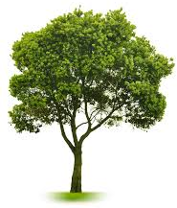
- Read and answer correctly.

- What are these?
_____________________________
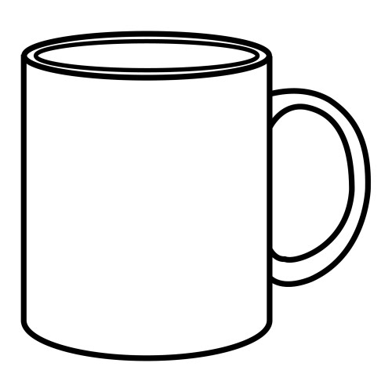
- Are these plates?
_____________________________
- Write these words correctly.
- ssdre __________________ (b) oonsp _________________
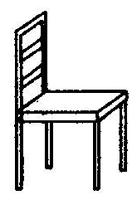
- Write a sentence about each picture.

- ________________________________
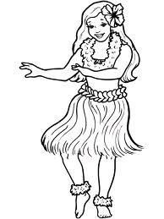

- ________________________________

- Write as instructed in each sentence.
- That is the girl. She lost her pencil. (Join using__who___)
______________________________________________________
- I came late to school. The teacher did not punish me. (Join using _______but____)
______________________________________________________
- I missed my lessons. I came late. (Join using ______because_____)
______________________________________________________
- Kato has gone to work. Wasswa has gone to work. (Begin: Both____________)
______________________________________________________
- I have a book. I have a pen. (Join using_____and ____)
______________________________________________________
- The old man is very tired. He cannot walk. (Use ___to__to___)
______________________________________________________
- My belt is as green as __________(complete correctly)
______________________________________________________
- The child is playing football. (Begin: The children____)
______________________________________________________
- I didn’t do the exams. I didn’t get a report. (Join using_________so_________)
______________________________________________________
- There are sixty minutes in an _______________(hour, our) (Choose the correct word)
______________________________________________________

SECTION B (50 Marks)
- Write the words with sound “oo” and “sh”.
“oo”
- ________________________ (c) _______________________
- ________________________

“sh”
(d) ________________________ (f) ________________________
(e) ________________________
- Match correctly.
people live in water.
pigs live in a kraal.
dogs live in a house.
fish live in a pigsty.
cows live in a kennel.
- people _______________________________________
- pigs _______________________________________
- dogs _______________________________________
- fish _______________________________________
- cows _______________________________________

- Use the table below to form correct sentences.
The children  He  She  They  The boy | have  has | made ropes.  made a mat.  played football.  sat on a bench.

- ______________________________________________________
- ______________________________________________________
- ______________________________________________________
- ______________________________________________________
- ______________________________________________________
- Re-arrange these sentences to form a good story.
- Then I go for jogging.
- When I reach school,
- On Monday I put on sportswear.
- I take my bag to class.
- My daddy takes me to school.
- ______________________________________________________
- ______________________________________________________
- ______________________________________________________
- ______________________________________________________
- ______________________________________________________

- Use these words to fill in the gaps below to form a good story.
food | played | animals | guides | zoo

On our trip, the P.2 class went to Entebbe __________________. When we reached there, the _________________took us round with our teachers and we saw many __________________. After that we _________________on the swings, climbing frames and the bouncing castles. Then we ate _______________and went back to school.
- Write a sentence for each picture.
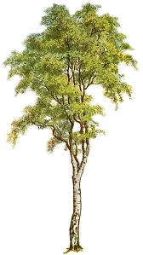

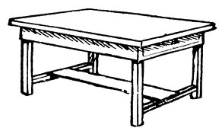

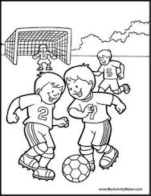

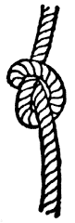

- Read the conversation and answer the given questions in full sentences.
My juice.
Jane: Hullo mummy.
Mummy: Hullo Jane.
Jane: Have you blended my juice?
Mummy: Yes, I have blended it and it’s in the fridge.
You should always take it because it is good
for your health.
Jane: Thank you mummy, my teacher told me that
it is good to feed on a balanced diet.
Mummy: That is great, your teacher is very good.
Everybody must feed on a balanced diet to
prevent diseases.
Questions:-
- Write the title of the conversation?
_______________________________________________________

- How many people are in the conversation?
_______________________________________________________
- What does Jane want from her mother?
_______________________________________________________
- What must everybody feed on?
_______________________________________________________
- Who told Jane that it is good to feed on a balanced diet?
_______________________________________________________
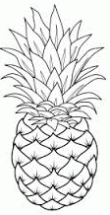
- Study the pictures and the words below to fill in the puzzle correctly.

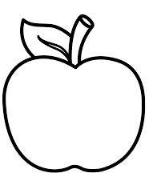
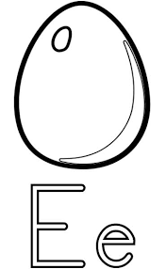

p

e

p

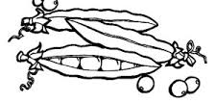

(peas, pineapple, egg, apple)

- Complete correctly.
- I am made of wood.
I have four legs.
People sit on me.
Who am I?
You are a ________________________________________

- I am made of sisal
You use me for skipping.
Who am I?
You are a __________________________________.

- I am made of clay.
You use me to keep water.
Who am I?
You are a ____________________________________.

- I am made of metal.
You use me to cut nails short.
Who am I?
You are a _____________________________________.

- I am round.
You make me out of banana fibers and sisal.
You use me for playing.
Who am I?
You are a _________________________________________
END.

